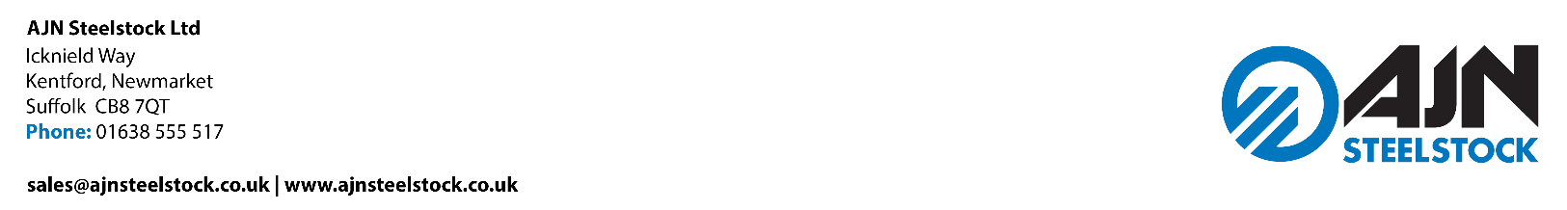

DELIVERY PLAN (DP)

Scope: Control of all delivery and collection vehicles and personnel while at the above address.

Purpose: To minimise risk while offloading or loading lorries, and during vehicle movement, by ensuring compliance with The Health and Safety at Work Act 1974 and other associated legislation.

- ARRIVAL AT AJN STEELSTOCK LTD

- Whenever possible a delivery time should be pre-arranged with our Purchasing team to avoid congestion within the Yard
- No parking is allowed immediately outside the site – please refer to next instruction
- All Drivers should telephone 01638 555 517 on the day of delivery (KENTFORD site only) and will either be asked to go direct to Kentford or to park at Risby Truck Stop (IP28 6RD) and await a phone call having left a mobile number with our Goods-In team
- Deliveries are strictly forbidden before 07:00 and after 12:00 noon (deliveries arriving before or after these times are likely to be refused)
- The Company can accept Articulated Flatbed, Articulated Slider, Articulated Curtainsider, Rigid and Box-type vehicles
- Reversing onto Company premises is strictly forbidden
- All Drivers must report immediately to Goods-In when arriving on site
- Drivers must follow all Health, Safety & Environmental directions at all times whilst on site
- Site speed limits must be observed and adhered to at all times.

- SITE AND PLANT

- Level hard standing areas are provided for offloading
- There are no specific height restrictions at our Kentford site
- The maximum bundle weight accepted is 4.8 tonnes, all Structural and Merchant bar will be unloaded by CombiLift, plate will be unloaded by either CombiLift or overhead crane, maximum bundle weights will remain the same (any bundles outside of the maximum weight limit must be agreed in advance)

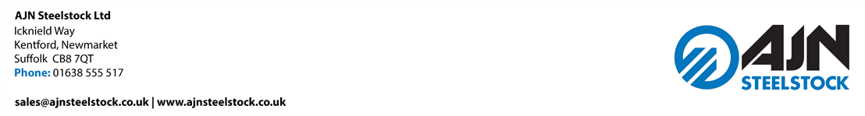

- The method of offloading will be dependant on the type of load that is to be delivered
- The maximum individual stock bar length is 18.3 metres, except for special requirements, which must be agreed in advance with the Health, Safety & Environmental team
- Suitable lifting gear and accessories, and additional control devices are available
- Additional CombiLift trucks with a 4 tonne SWL and Counter Balance Forklift trucks with a 3 tonne SWL are also available
- Steps are available on request to allow Drivers safe access/egress onto their lorry bed
- The former will only be allowed, if there is fall protection in place.

- SAFETY ARRANGEMENTS

- A hardhat, safety footwear and high visibility vest or jacket must be worn at all times
- The wearing of shorts is strictly forbidden
- Passengers or animals travelling with the Driver are not permitted to leave the lorry cab at anytime
- The parking brake should always be applied to any stationary vehicle
- During the unloading process the Driver must remain in their cab until the unloading process is complete
- The Driver should only access the lorry bed using the equipment supplied by AJN
- The Driver will not be allowed on the lorry bed during the offloading process
- At no time is the Driver authorised to operate any lifting equipment
- Drivers are not allowed to take part in the lifting operation; this includes the slinging of any loads
- All steel loads should have sufficient timber bearers to allow safe offloading
- No vehicle movements are to take place unless all load items are properly secured
- Tipping, barring off, dragging off, or manually offloading of steel will not be carried out at this site
- No reversing is to be carried out, unless instructed to do so by a member of AJN staff (AJN does not use banksmen as it is considered unsafe to do so)
- AJN has sufficient First Aiders
- All accidents or environmental incidents however minor must be reported to a member AJN staff.

FAILURE TO ADHERE TO THE SITE ‘DP’ COULD RESULT IN THE DELIVERING VEHICLE BEING EJECTED FROM SITE!

